Laktose-tolerans
http://da.wikipedia.org/wiki/Laktoseintolerans

Laktoseintolerans
Fra Wikipedia, den frie encyklopædi
Laktoseintolerans er en mindsket egenskab til at fordøje laktose, som er det dominerende sukker i mælk. De fleste med laktoseintolerance kan drikke 1/4 liter mælk pr. dag uden at få problemer, men ved et højere indtag vil man få luft i maven og efterfølgende få ondt og evt. diarre. ^{[1]}
Andre mælkeprodukter som yoghurt indeholder mindre laktose end mælk, mens hårde oste kan være helt fri for laktose. Det er vigtigt at understrege at laktose-intolerance ikke er det samme som mælkeallergi.
Fra fødslen produceres enzymet laktase i tyndtarmen hos mennesker og andre dyr. Dette enzym er en forudsætning for at kunne fordøje modermælk. Der produceres mindre laktase efter afvænning og ændring til en mere voksen kost. I store dele af verden synker laktaseværdierne hos børn fra 2- til 8-års-alderen. Hos teenagere og unge voksne er produktionen reduceret til 1/10 af spædbarnsniveauet. Værdien holder sig så stabil resten af livet.

Geografisk fordeling
I mange områder i verden er det derfor normalt at voksne ikke drikker særlig meget mælk. I USA regner man med at mælk giver fordøjelsesproblemer hos 50% af alle af spansk herkomst og mindst 75% af alle af afrikansk, asiatisk og indfødt amerikansk herkomst.

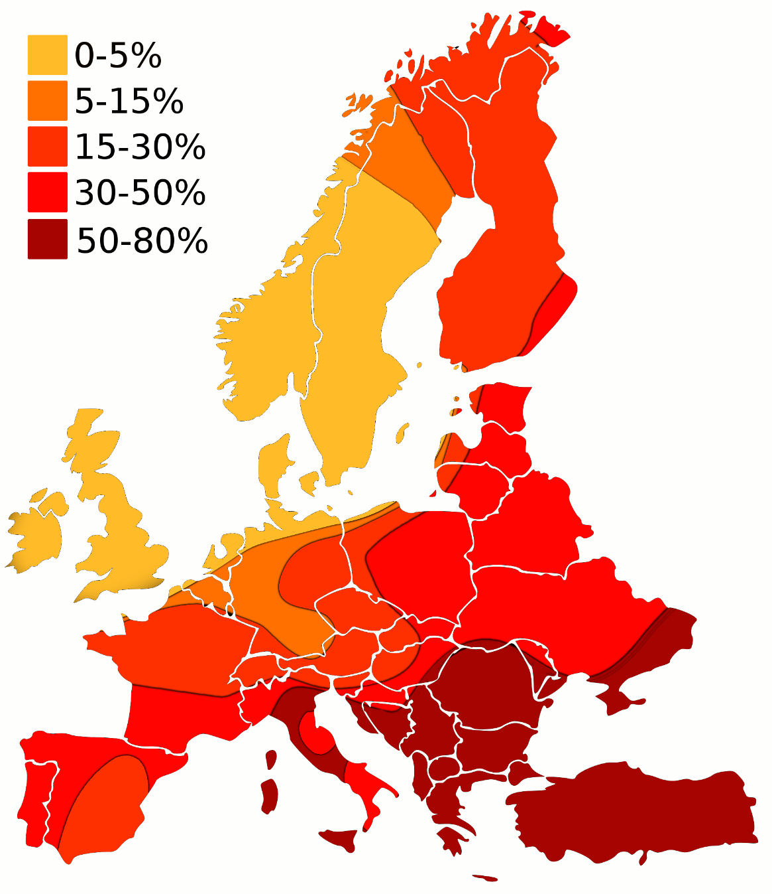
Andel af laktoseintolerante i Europa
Laktaseniveauet holder sig typisk højt for befolkningsgrupper som tidligere har haft begrænset mulighed for at dyrke jord på grund af klima eller andre årsager og dermed været afhængige af mælk fra dyr for at overleve. I Skandinavien ligger andelen med laktoseintolerance på ca. 5%, i Centraleuropa stiger den til ca. 15% og er på over 50% i Sydeuropa. Den er på 70–90% i Afrika (undtagen for mange nomadegrupper), 80% i Centralasien, 90% i Østasien, 30% i Nordindien, 70% i Sydindien og 65% i Sydamerika. ^{[2]}

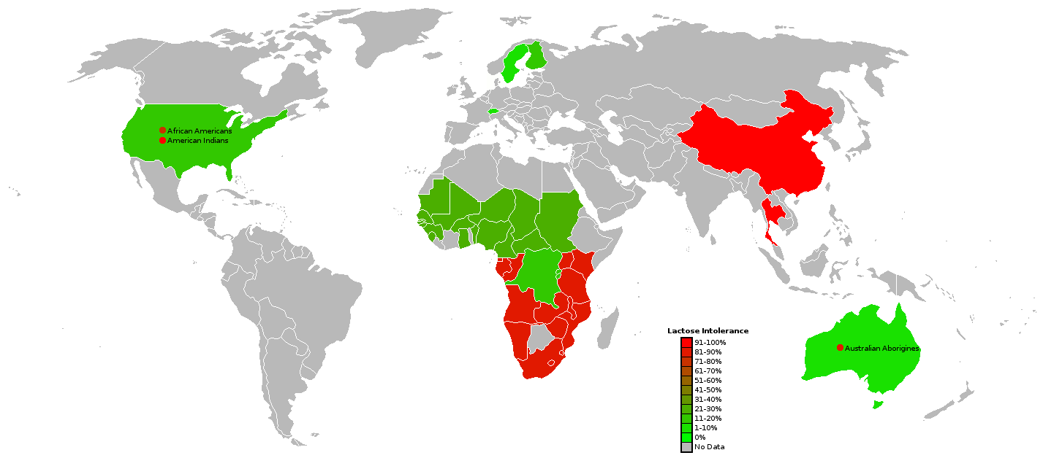
Andel af laktoseintolerante i udvalgte lande
Et par studier har også vist at ved at drikke en mindre mængde mælk flere gange i løbet af dagen over flere uger kan man optræne bakterierne til at fordøje mælken mere effektivt. ^{[3]}

Genetisk baggrund
LCT-genet, der koder for laktase-enzymet, findes på kromosom-par nr. 2. Flere DNA-regioner (promoter, enhancers og silencers) omkring LCT-genet deltager i at styre aktiviteten af genet. En af disse regulerende DNA-regioner har vist sig at være genet MCM6, som findes ca. 13000 basepar fra LCT-genet. MCM6 koder for et regulatorisk protein, som er med til at starte transskriptionen af LCT-genet.
Det har vist sig at en enkelt-nukleotid variation (SNP) i MCM6-genet, formentligt har betydning for produktionen af laktase blandt voksne, og dermed for hvorvidt de udvikler laktose-intolerans. Et enkelt nukleotid i MCM6-genet (-13910 basepar fra LCT) har C/T polymorfi, dvs. individer med genotypen T-T eller individer med C-T (heterozygote) er ikke laktose-intolerante. Mens individer med genotypen C-C er fænotypisk laktose-intolerante, idet de producerer mindre laktase. Flere andre SNP's menes dog også at spille en rolle i laktose-fordøjelsen^{[4]} og kan identificeres med en gen-test (RFLP, DNA-chip eller lignende).
Allelen af MCM6 med T på den afgørende position (-13910 fra LCT), som er med til at give mælkefordøjelse hele livet, menes at være opstået ved en tilfældig mutation. Derefter har den bredt sig ved naturlig selektion gennem de sidste ca. 10.000 år, idet individer med denne allel kan have haft en evolutionær fordel, specielt i tider med fødemangel.^{[5]}

Eksterne links og referencer
- Laktosetolerencetest (Mælkesukkertest). Netdoktor.dk

- Hoppe op ↑ Studies on the etiology of milk intolerance in Japanese adults, Yoshida Y, Sasaki G, Goto S, Yanagiya S, Takashina K, Gastroenterol Jpn.;10(1):29-34, 1975.
- Hoppe op ↑ Gene Expression: Lactose tolerance/intolerance.
- Hoppe op ↑ Purdue University: Lactose intolerance? Drink more milk.
- Hoppe op ↑ Troelsen J T (2005) "Adult-type hypolactasia and regulation of lactase expression" Biochimica et Biophysica Acta 20 1723 pp 19-32
- Hoppe op ↑ http://videnskab.dk/krop-sundhed/maelk-giver-storre-chance-overlevelse

http://evolution.berkeley.edu/evolibrary/news/070401_lactose
Got lactase?
April 2007
In the US and many other countries, we've certainly "got milk," but not everyone can enjoy it. For around 10% of Americans, 10% of Africa's Tutsi tribe, 50% of Spanish and French people, and 99% of Chinese, a tall cold glass of milk means an upset stomach and other unpleasant digestive side effects. In fact, most adults in the world are lactose intolerant and cannot digest lactose, the primary sugar in milk. And yet, regardless of our ancestry, most of us began our lives happily drinking milk from a bottle or breast — so what happened in the intervening time? Why do so many babies enjoy lactose and so many adults avoid it? Lactose is broken down by a protein called lactase, which acts as a pair of molecular scissors, snipping the lactose molecule in two. Anyone who drank milk as a baby carries a working version of the gene that codes for lactase. In lactose tolerant individuals, that gene keeps working into adulthood, producing the protein that digests lactose and makes eating ice cream a pleasant experience. But in people who are lactose intolerant, that lactase gene is switched off after weaning. Now, new research reveals that the Stone Age ancestors of European dairy-lovers probably couldn't digest milk either. So how did they get from bellyaches to milk mustaches? The answer is an evolutionary story that takes us from the milkmaids of the Alps to the Maasai herdsmen of Africa.
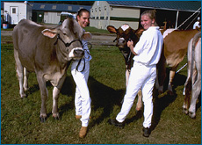 |  | 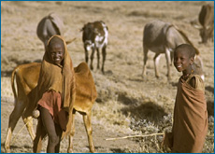
Prevalance of lactose tolerance and reliance on dairy products vary throughout the world.

Where's the evolution?
Mutations that keep the lactase gene permanently switched on are common among modern Europeans — but not among their ancestors. In March 2007, a team of German and British researchers announced that they went looking for that mutation in the 7000-year-old fossils of ancient Europeans and came up empty-handed. The researchers managed to extract the length of DNA corresponding to the lactose tolerance mutation from eight Neolithic human fossils and one Mesolithic fossil, but those DNA sequences did not carry the telltale mutation. The results suggest that as late as 5000 BC most ancient Europeans could not have digested milk as adults — and that they only later evolved into milk-drinking societies.
Today, the ability to digest milk as an adult seems like a clear benefit, but that wasn't always the case. Lactose tolerance is only advantageous in environments and cultures where humans have access to domesticated dairy animals. Multiple lines of evidence from human genetics, cattle genetics, and archaeological records suggest that Middle Eastern and North Africans populations domesticated cattle between 7500 and 9000 years ago, and that these animals were later brought into Europe. In that cow-friendly environment, being able to drink milk directly (instead of having to process it into lower-lactose cheese) would have been advantageous, providing additional sustenance and, during droughts, a source of water. The lactose tolerance mutation arose randomly (as all mutations do), but once it arose, it had a distinct advantage in these populations. Natural selection would have favored individuals carrying the lactose tolerance mutation, spreading it through ancient European populations that depended on dairying. Many thousands of years later, we see the indirect (but delicious) effects of this mutation's success in European cuisines: oozing French cheeses, Swiss milk chocolate, and creamy Italian gelatos.
How do we know?
How did Sarah Tishkoff's team identify the African lactose tolerance mutations and show that they had been advantageous? To identify the mutations, the team collected DNA samples from African participants and tested those same individuals for lactose tolerance. They looked for mutations in the DNA samples that always showed up in lactose tolerant individuals but weren't found in lactose intolerant individuals. To double check that the candidate mutations they'd identified weren't red herrings, the team then did Petri-dish-style experiments, which helped show that those signature mutations were likely to keep the lactase gene turned on.
To show that the mutations were advantageous, the team looked for evidence of what geneticists call a "selective sweep" — the rapid spread of an advantageous mutation through a population that simultaneously spreads the DNA sequences adjacent to the new mutation. To understand how selective sweeps work, consider this hypothetical example. Imagine that a new advantageous mutation occurs on Chromosome 4, right next to, say, a gene coding for bushy eyebrows and a gene coding for black hair. In genetic terms, we would say that the mutation and those genes are "linked" — that is, they are close together on the same chromosome. The new mutation is so advantageous that its carrier leaves lots of offspring — many of whom carry the mutation and the other linked genes. As natural selection spreads this mutation, it tends to bring along nearby gene versions (bushy eyebrows, black hair). Those neutral gene versions can hitchhike their way to high frequency along with an advantageous mutation if they are very closely linked — so a large portion of the population might wind up carrying the genes for black hair and bushy eyebrows, even though these traits are not particularly advantageous. Of course, over time recombination tends to break down the associations between nearby genes, but in a selective sweep, the mutation spreads so rapidly that recombination doesn't have time to break the genetic alliance up much. The faster the sweep, the less the alliance can be broken up, and the slower the sweep, the more the alliance can be broken up.
Tishkoff's team studied their DNA samples to see how much of the genetic sequences surrounding the lactose tolerance mutations had been swept to high frequency along with the advantageous mutations. A surprisingly large portion of the chromosome seems to have escaped the dissociating effects of recombination and "come along for the ride" offered by lactose tolerance. Based on these studies, Tishkoff's team estimates that the most successful of the African lactose tolerance mutations arose within the last 7000 years and quickly spread through dairying populations.

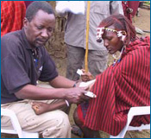
A Maasai warrior donates blood for a DNA sample.
Surprisingly, with respect to dairying, human populations on separate continents seem to have led parallel lives — or rather, followed parallel evolutionary trajectories. Recent evidence suggests that cattle may have been domesticated independently in several places, including Africa. As African populations began herding cattle, lactose tolerance became an advantageous trait. The stage was set, in Africa too, for the spread of a lactose tolerance mutation. In January 2007, an international team of researchers led by geneticist Sarah Tishkoff announced that they had uncovered the genetic roots of Africans' lactose tolerance. Just as in Europe, on this continent, mutations (in this case, probably three) randomly arose, and these happened to have the effect of keeping the lactase gene switched on. And just as in Europe, these mutations were favored by natural selection and quickly spread through dairy-dependent populations.
While this discovery answers many questions, it also highlights new mysteries. For example, Tishkoff's team discovered that in the Hadza population (a group of Tanzanian hunter-gatherers), around 50% are lactose tolerant — a percentage usually indicative of a dairy-dependent society. And yet, as far as is known, the Hadza have never had much to do with cattle or relied on milk in their diets — so what explains their lactose tolerance? Are they the long lost descendents of a group of cattle herders? Has the tribe changed its basic mode of making a living? Or could the lactose tolerance mutation provide some other yet-to-be-discovered advantage, beyond allowing adults to drink milk?
Whatever the answers such spin-off questions, research into the evolutionary origins of lactose tolerance has already clearly illuminated some fascinating aspects of human evolutionary history. Perhaps most intriguingly, the convergent evolution of African and European populations in relation to cattle domestication reveals that shared aspects of human culture across different ethnic groups affects our evolution in similar ways. Regardless of skin color or geography — whether dealing with Stone Age Europeans, Swiss milk maids, Maasai warriors, or modern hunter-gatherers — evolution plays by the same rules.
Read more about it
Primary literature:
- Burger, J., Kirchner, M., Bramanti, B., Haak, W., and Thomas, M. G. (2007). Absence of the lactase-persistence-associated allele in early Neolithic Europeans. Proceedings of the National Academy of Sciences USA 104(10):3736-3741.
- Check, E. (2007). How Africa learned to love the cow. Nature 444:994-996.
- Tishkoff, S. A., Reed, F. A., Ranciaro, A., Voight, B. F., Babbitt, C. C., Silverman, J. S., Powell, K., Mortensen, H. M., Hirbo, J. B., Osman, M., Ibrahim, M., Omar, S. A., Lema, G., Nyambo, T. B., Ghori, J., Bumpstead, S., Pritchard, J. K., Wray, G. A., and Deloukas, P. (2007). Convergent adaptation of human lactase persistence in Africa and Europe. Nature Genetics 39:31-40.
News articles:
- A kid-friendly description of Sarah Tishkoff's genetic studies from the University of Maryland
- A news article on the search for a lactose tolerance mutation in Neolithic fossils from BBC News
- A thorough summary of the discovery of lactose tolerance mutations in Africa from the UM Newsdesk
Understanding Evolution resources:
- An in-depth review of the process of mutation
- A news brief describing research on the evolution of another human trait — skin color
- A research profile of biologist Chelsea Specht who studies evolutionary convergence in plants
Discussion and extension questions
- Are you lactose tolerant or lactose intolerant? Based on the information in this article, explain how your genes affect your ability (or lack of ability) to digest milk.
- Read about the concepts of genotype and phenotype. Explain how these concepts apply to a lactose tolerant individual.
- Review some background information on natural selection. Explain how a lactose tolerance mutation would spread through a human population that herds cattle. Make sure to include the concepts of variation, selection, and inheritance in your explanation.
- Now imagine that the population described in the question above lived during the Paleolithic before any animals were domesticated. How would that change your answer to the question above?
- In evolutionary terms, why is it surprising that many Hadza are lactose tolerant?
- This article describes an example of convergent evolution in humans. Research a different example of convergent evolution in another organism. Explain, in general terms, how that trait evolved in the different organisms.
Related lessons and teaching resources
- Teach about natural selection: This board game for grades 9-12 simulates natural selection. It is suitable for an introductory biology class and for more advanced classes where you could go into more detail on important principles such as the role of variation and mutation.
- Teach about human evolution at a molecular level: In this lesson for grades 9-12, students investigate variation in the beta globin gene by identifying base changes that do and do not alter function, and by using several internet-based resources to consider the significance in different environments of the base change associated with sickle cell disease.
References
- Burger, J., Kirchner, M., Bramanti, B., Haak, W., and Thomas, M. G. (2007). Absence of the lactase-persistence-associated allele in early Neolithic Europeans. Proceedings of the National Academy of Sciences USA 104(10):3736-3741.
- Central Intelligence Agency. (2007, March 15). The world factbook: United States.
Retrieved March 27, 2007 from https://www.cia.gov/cia/publications/factbook/print/us.html
- Check, E. (2007). How Africa learned to love the cow. Nature 444:994-996.
- National Digestive Diseases Information Clearinghouse. (2006, March). Lactose intolerance.
Retrieved March 27, 2007 from http://digestive.niddk.nih.gov/ddiseases/pubs/lactoseintolerance/
- Tishkoff, S. A., Reed, F. A., Ranciaro, A., Voight, B. F., Babbitt, C. C., Silverman, J. S., Powell, K., Mortensen, H. M., Hirbo, J. B., Osman, M., Ibrahim, M., Omar, S. A., Lema, G., Nyambo, T. B., Ghori, J., Bumpstead, S., Pritchard, J. K., Wray, G. A., and Deloukas, P. (2007). Convergent adaptation of human lactase persistence in Africa and Europe. Nature Genetics 39:31-40.
- Wade, N. (2007, December 11). Lactose tolerance in East Africa points to recent evolution. The New York Times.
Retrieved March 27, 2007 from http://www.nytimes.com/2006/12/11/science/11evolve.html?ex=1323493200&
en=a2ded9bbd0241eaf&ei=5088&partner=rssnyt&emc=rss

First image of cattle and people is provided by USDA; second image of cattle and people provided by Dr. Robert Thomas and Margaret Orr © California Academy of Sciences; photo of Maasai warrior giving a blood sample provided by Sarah Tishkoff

